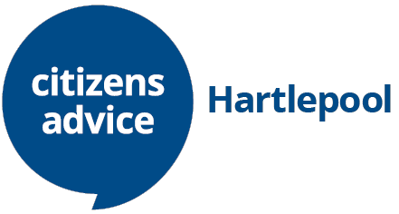

Cookies

When you browse our website, we collect ‘cookies’ to help us understand more about how our site is used by visitors, and to develop and enhance our services to you.
A ‘cookie’ is a bit of information kept on your computer. It tells us things like what device you’re using and what pages you click on.
We use cookies to:
- track aspects of user visits, including the length of a user’s visit, their browser, geographic location and the use of the search facility on this website
- remember users selected contrast and/or text resizing style preferences for this website
- record a user’s video preferences for our YouTube videos viewed on this website.

How to manage or delete cookies
If you don’t want to receive cookies, you can change settings in your web browser so that your browser tells you when cookies are sent to it or you can refuse cookies altogether. You can also delete cookies that have already been set.
If you wish to restrict or block web browser cookies, the Help function within your browser should tell you how. Alternatively, these sites can provide more information on how to do this:
www.allaboutcookies.org www.aboutcookies.org
This privacy policy only covers this website citizensadvice.org.uk and it’s subdomains; other websites linked from this website are not covered by this policy. Once you have accessed another website via one of our links you will be subject to the security and privacy policy of that site.

‘Find out more’: How we use cookies - Citizens Advice

Contact us about your data
You can contact us at any time and ask us:
- what information we’ve stored about you
- to change or update your details
- to delete your details from our records
Send us a message at enquiries@hartlepool.cabnet.org.uk

